**TASK REPORT – TO-DO LIST WEB APPLICATION---DAY 2**

**Interactive To-Do List Web Application with Priority, Countdown, Themes, and Progress Tracking**

**Task Description:**

This is a web-based To-Do List application that allows users to manage their daily tasks with advanced features like priority tagging, countdown timers, progress visualization, search, filters, and customizable themes. The app provides an interactive and engaging experience with celebratory animations and sound feedback on task completion.

**Key Features Implemented:**

* Task creation with name, due date & time, and priority.
* Task editing and deletion.
* Marking tasks as completed.
* Countdown timer showing time left for each task.
* Priority badges: High (Red), Medium (Yellow), Low (Green).
* Dark mode toggle and additional color themes: Peach and Aqua.
* Task filters by completion status and priority.
* Live search functionality.
* Progress bar reflecting overall completion percentage.
* Celebration GIF and audio on task completion.

**Technologies Used:**

* **HTML** – for page structure.
* **CSS** – for styling, animations, and responsive layout.
* **JavaScript** – for logic, event handling, DOM manipulation, and localStorage management.

**Learnings:**

1. **DOM Manipulation**  
   Gained hands-on experience in dynamically updating HTML elements using JavaScript and handling real-time data rendering in tables.
2. **Working with localStorage**  
   Understood how to persist data in the browser without a backend by using localStorage to save and retrieve tasks.
3. **Date and Time Handling**  
   Learned to work with the Date object to implement countdown timers, format date & time, and compare task deadlines.
4. **Event Handling**  
   Developed better understanding of adding event listeners to buttons, input fields, and select elements to trigger actions.
5. **Theming with CSS**  
   Practiced using CSS variables (:root) and dynamic class toggling for switching themes and adding animation effects.
6. **UI/UX Design**  
   Explored how small visual cues (like progress bars and animated celebrations) can enhance user experience.
7. **Code Optimization and Modular Thinking**  
   Understood how to structure reusable functions (renderTasks, toggleComplete, filterTasks, etc.) for better code clarity and maintenance.

**SCREENSHOTS:**

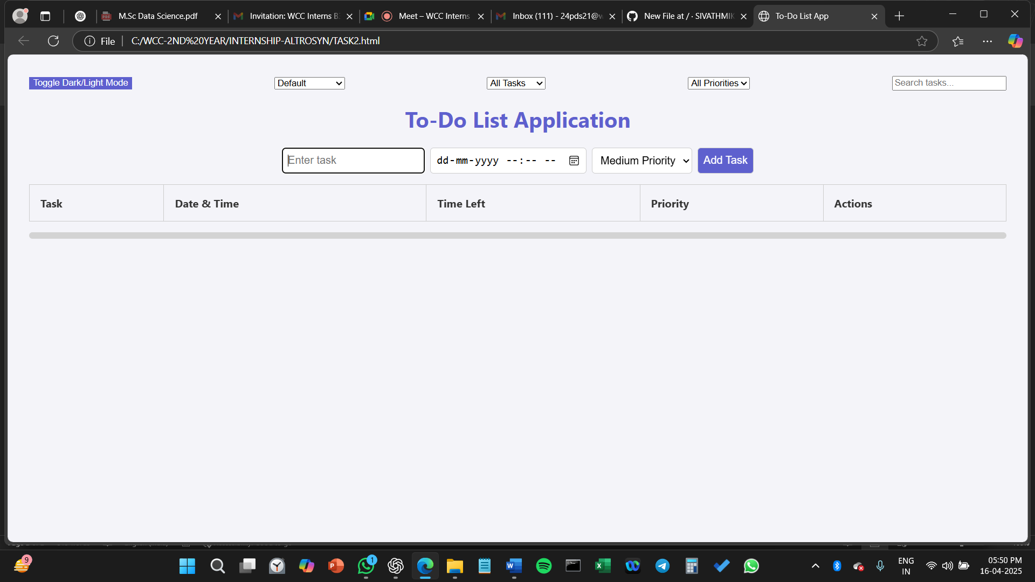

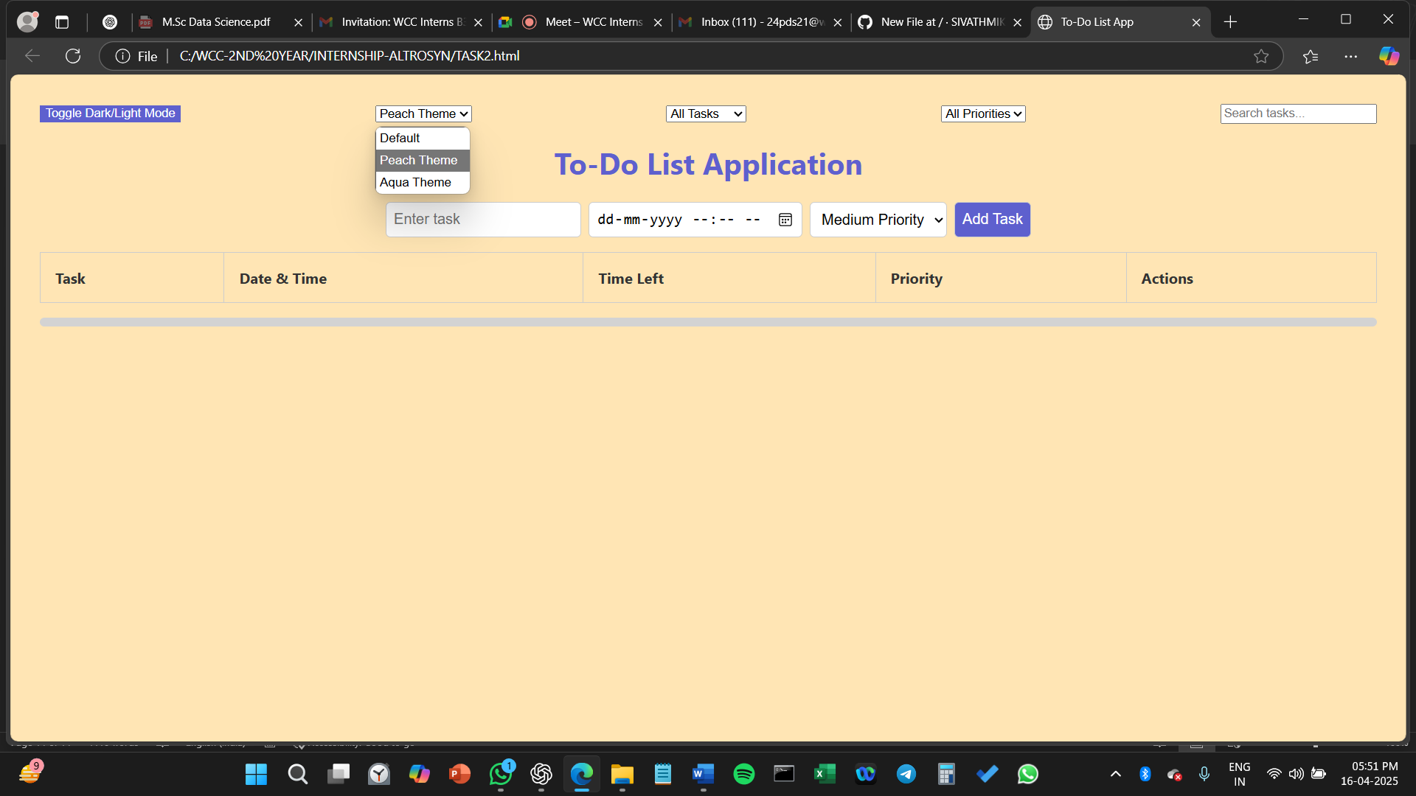

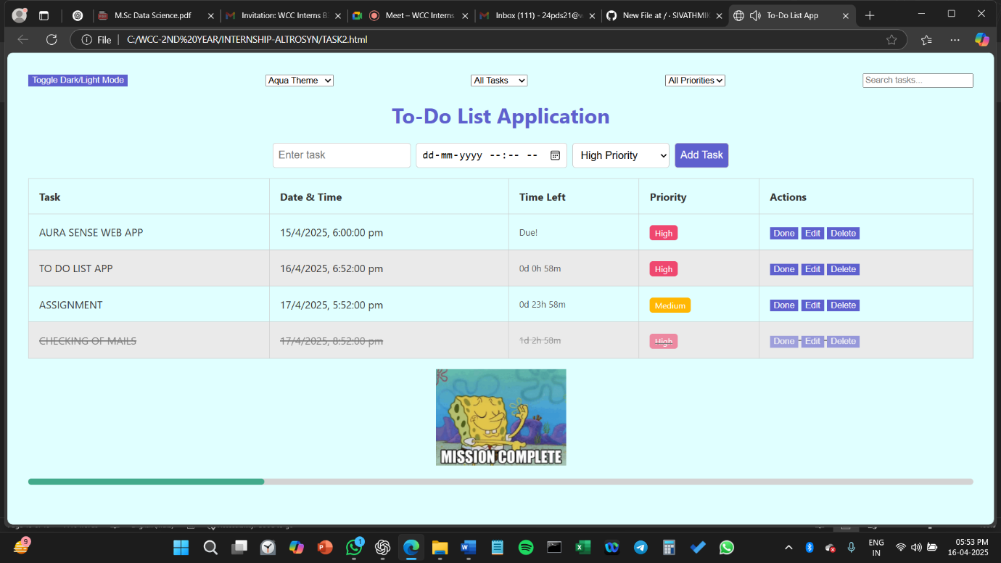

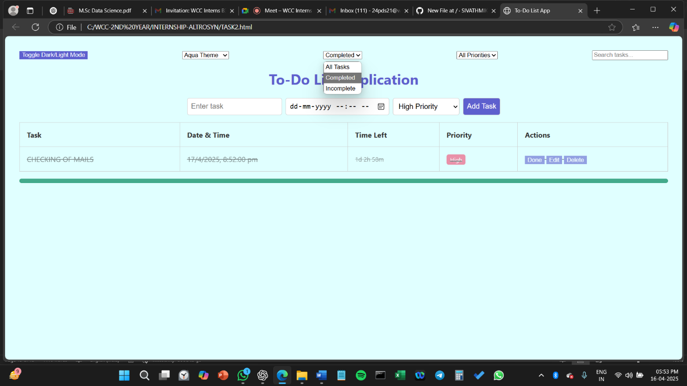

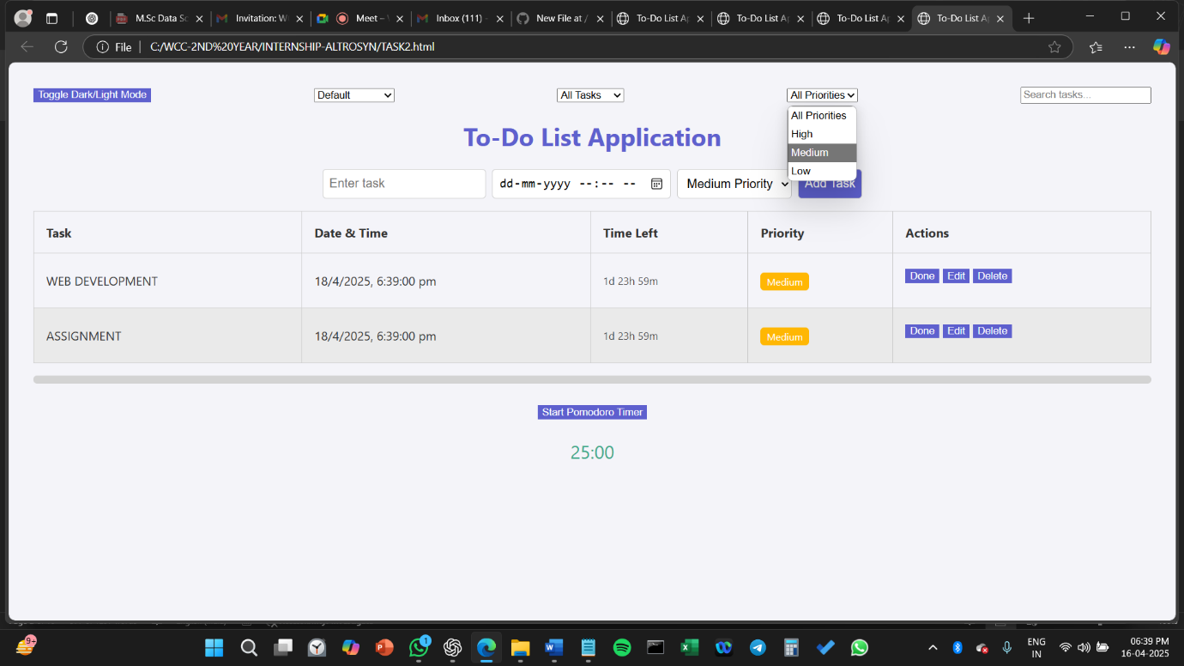

**GITHUB LINK:**

[**SIVATHMIKAC/TO-DO-LIST-**](https://github.com/SIVATHMIKAC/TO-DO-LIST-)